[Organisation] · PHASE A · TEMPLATE T-02
Architecture Vision
First ADM cycle — [Organisation] 2030, Wave 1
Field | Detail
Version | 0.1 — Draft, for Architecture Board approval
Date | April 2027
Owner | Chief Enterprise Architect
Approver | Architecture Board, on the sponsor's Statement of Architecture Work
Constraint | Ten pages maximum, per template T-02.
Classification | Internal

1. Business need
[Organisation] holds 1.9 million policies across five lines of business and cannot recognise a customer who holds three of them. Claims settle in eleven days against a promise of two. A broker waits two and a half days for a quote a competitor returns in an hour. Each of these is separately survivable and together they describe a group that operates as five insurers sharing a balance sheet. Wave 1 exists to make [Organisation] one company to deal with, starting with the identity that everything else depends on.

2. Stakeholders and their concerns
Summarised. The full set of thirty-two stakeholders, with power, interest, ability to disrupt and commitment, is in the Stakeholder Map.

Stakeholder | Class | Principal concern
Group Executive Committee | Key player | Delivering [Organisation] 2030 without a third failed transformation.
Chief Financial Officer | Key player | Costed work packages with a funding source named for each.
Chief Data Officer | Keep informed | Four customer masters, no data owners, lineage in spreadsheets.
Chief Information Officer | Key player | Delivery capacity, run cost at 71%, and whether architecture slows delivery.
Prudential Authority and FSCA | Key players | IT risk ownership under Joint Standard 1, and conduct outcomes evidenced from systems.
Line of business Managing Directors | Keep satisfied | Whether the shared platform makes their book faster or slower. Commitment 2 against a required 4.
Independent brokers | Key player | Whether integration change makes [Organisation] easier or harder to place business with.
Delivery teams | Keep informed | A stable design at G2 and a change route that does not require starting again.

3. Baseline in summary
Domain | What is true today | Why it matters
Customer | Four systems master customer data with no shared identifier. Roughly 640,000 records cannot be matched. | A data subject access request cannot be answered completely, and no operational process can see the whole customer.
Claims | Two claims systems by line of business. Parlour notifications arrive by telephone and are rekeyed. Authorisation requires a separate policy lookup. | Median funeral settlement is eleven days against a promise of two. Leakage is 4 to 6% of R21.4bn.
Distribution | Broker submissions arrive by email attachment or overnight file. Rating factors sit inside the policy system. | Quote-to-issue is 31% digital. Eleven weeks to reprice motor against a market that moves in days.
Integration | Roughly sixty interfaces, forty-four unmanaged, four reading another application's database directly. | Every new integration adds to the problem because there is no managed route to add it to.
Governance | No body has been able to withhold approval of a design. ACMM element E8 scores 1.0. | Twenty-six principles, twenty-two security principles and a tailored framework exist and none is enforceable.

4. Target in summary
Domain | What must become true | Note
Customer | A match-and-link identity hub resolves customers across the four masters without replacing any of them. | ADR-031. Deliverable incrementally and abandonable if it does not work.
Claims | One claims workflow carrying notification, assessment, authorisation and settlement, with policy and history in view. | Consolidates two claims systems. Parlour network served by one portal, not per-parlour integration.
Distribution | Broker submission through the managed API, and rating factors held outside the policy administration system. | ADR-032 and ADR-033. The existing file route continues during transition.
Integration | A managed integration layer through which all new integration is routed, authenticated and logged. | WP-02. Existing interfaces migrate by wave rather than in one move.
Governance | An Architecture Board that can withhold approval, a Design Authority sitting weekly, and materiality triage with a five working day commitment. | CAP-WP-01. Nothing else in the capability is enforceable until this is done.

5. Value proposition
Stated as capability movement, assessed at level 3.

Capability | Now | Target | What changes
Customer Management | 1.6 | 3.0 | From four masters to one resolved identity, with lawful purpose travelling with the data.
Claims Management | 2.1 | 3.0 | From rekeyed notification and separate lookups to one workflow with history in view.
Distribution & Channel | 2.3 | 3.0 | From file transfer and manual quoting to submission by API with indicative pricing.
Enterprise Enablement | 2.5 | 3.2 | From forty-four unmanaged interfaces to a managed route for all new integration.
Risk, Compliance & Financial Crime | 2.8 | 3.2 | From governance that cannot refuse to governance that can, and evidences it.

6. Key performance indicators
Indicator | Baseline | Wave 1 target | By | Owner
Customer records resolved to a single identity | 62% | 80% | Q4 2028 | Chief Data Officer
Median days to settle a funeral claim | 11 days | 4 days | Q4 2028 | Claims Executive
Quote-to-issue completed without manual intervention | 31% | 55% | Q4 2028 | Chief Distribution Officer
Interfaces under management | 16 of 60 | 45 of 60 | Q4 2028 | Application Domain Architect
Conduct outcomes reportable from systems of record | 12% | 60% | Q4 2028 | Chief Compliance Officer
Architecture maturity, ACMM weighted mean | 2.0 | 2.6 | Q4 2028 | Chief Enterprise Architect

7. Conduct and prudential exposure
From the exposure screen, template T-03. Material exposure routes to the Risk Committee in parallel with the Architecture Board.

Question | Answer | Detail
Does the change affect a customer-facing outcome? | Yes | Servicing, claims and sale are all touched. Conduct outcomes engaged: advice, sale, servicing, claim.
Does it affect a regulatory return? | Yes | Conduct outcome reporting and the POPIA access response. IFRS 17 lineage is affected indirectly through the data platform.
Does it affect the solvency capital requirement? | No | Consulted with Group Actuarial. No change to the reserving basis or capital model in Wave 1.
Personal data engaged | Yes | Party, contact detail, claim and advice record. Classification Restricted; lawful basis must propagate.
Obligations engaged | OBL-01, OBL-05, OBL-06, OBL-10, OBL-21 | Conduct outcomes, lawful basis, purpose propagation, subject access, and asset ownership.
Materiality of exposure | Material | Routed to the Risk Committee in parallel, not at the end of the escalation ladder.

Exposure is material
Conduct outcomes, lawful basis, purpose propagation and subject access are all engaged. The Risk Committee receives this vision at the same time as the Architecture Board, not after it.

8. Transformation risks
Risk | Likelihood | Impact | Mitigation | Owner
This becomes a third failed transformation | Medium | Severe | Transition Architectures mandatory at every wave boundary, each stating the cost of stopping there. ADR-029. | Chief Enterprise Architect
Identity is built on before ownership is designated | High | High | Authoritative source designation by the Data Governance Council precedes build. The hub queues unresolved matches rather than guessing. | Chief Data Officer
The Portfolio Architect post stays vacant | Medium | High | Model A currently runs on the Chief Enterprise Architect's residual time. Filling the post is CAP-WP-05. | Chief Information Officer
Architecture becomes the reason a gate slips | High | Medium | Materiality triage with a published five working day commitment, and deemed approval at Materiality 3. | Chief Enterprise Architect
Funding is deferred beyond FY2028 | Medium | High | Change is funded from run-cost reduction. A work package with no named funding source is not scheduled. | Chief Financial Officer
Line of business commitment does not move | High | Medium | Three key stakeholder groups sit two levels below the commitment needed. Addressed through capability analysis per line, not through briefing. | Business Domain Architect

9. Solution concept
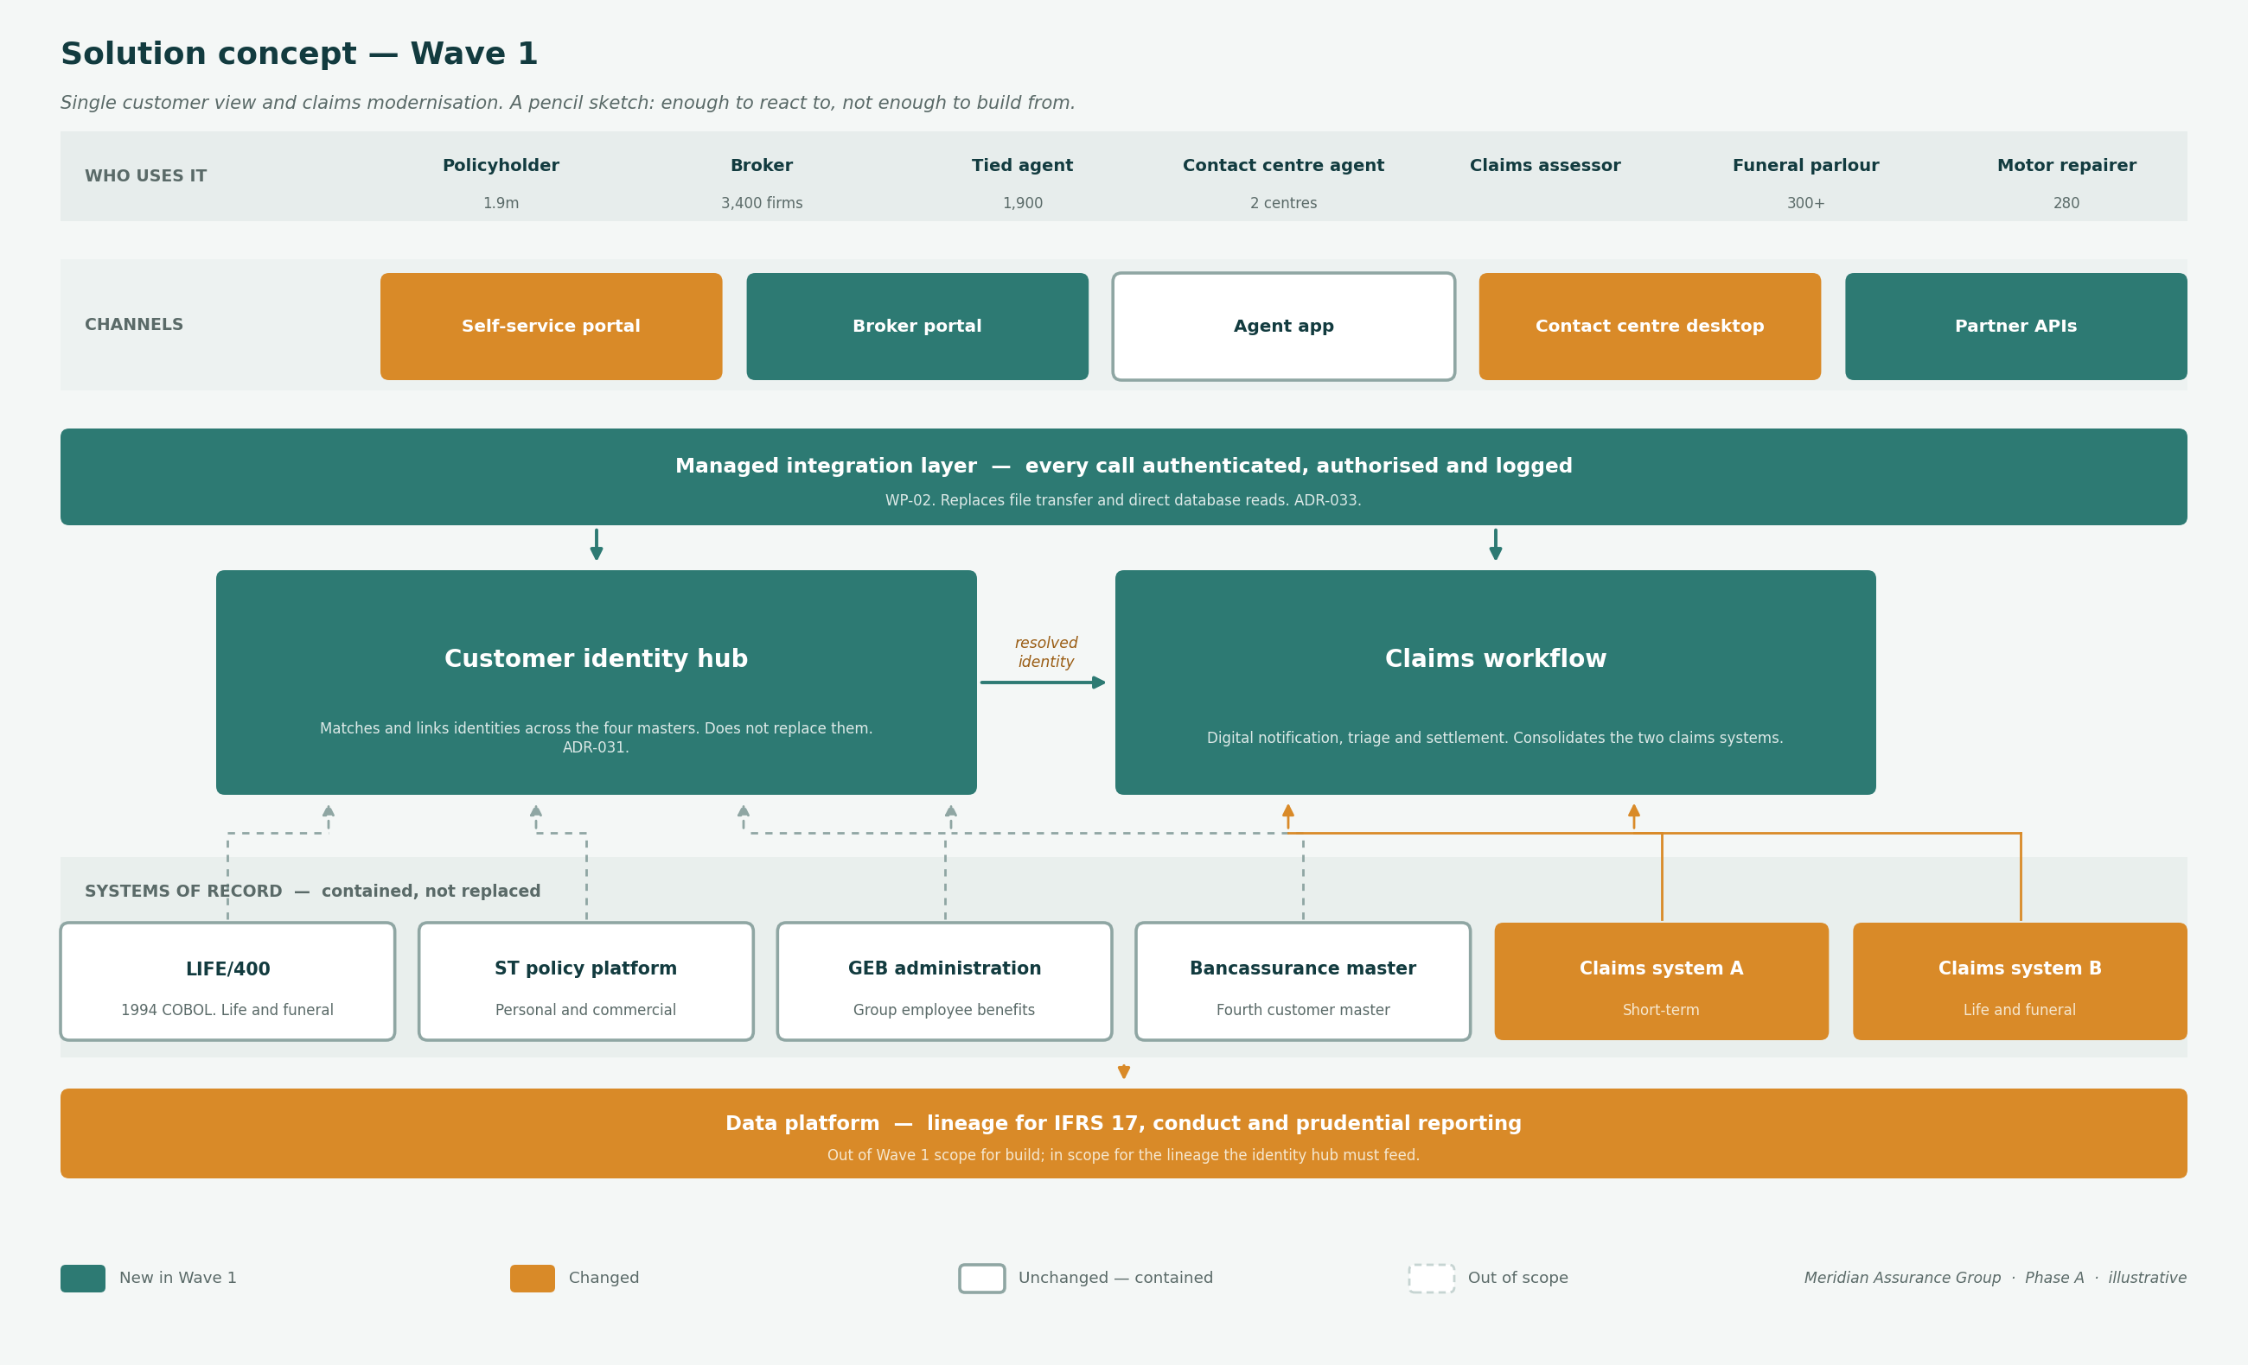
The Wave 1 solution concept. Green is new, amber changed, outlined contained and unchanged.

10. Scope and constraints
In scope
- Customer identity resolution across the four masters
- Claims notification, assessment, authorisation and settlement for funeral and short-term
- Broker submission and indicative quoting for commercial
- The managed integration layer beneath all three
- Constituting the Architecture Board and the Design Authority
Out of scope
- Replacement of LIFE/400 or any policy administration platform
- [Organisation] Namibia and [Organisation] Botswana, which are federated by design
- Investments and Marketing & Brand, which have no architecture engagement
- The IFRS 17 sub-ledger, which is re-platformed in Wave 2
- Any change to the reserving basis or capital model

Constraint | Consequence
No incremental budget before FY2028 | Change is funded from run-cost reduction under COA-10.
Fourteen architects, two posts vacant | Depth of architecture is set by materiality, not by phase.
Two failed core replacements | Increment size is bounded by what the organisation has previously absorbed.
Regulatory dates do not move | COFI transition, IFRS 17 cycles and Joint Standard deadlines are fixed inputs.
Principles are not yet ratified | Until the Architecture Board sits, this vision is a recommendation rather than a position.

11. Approval
This vision is a recommendation until the Architecture Board has been constituted and has ratified the principles it rests on. That is not a formality: every architectural position in this document is currently unenforceable, and the first work package exists to change that.

Role | Name | Signature | Date
Chief Enterprise Architect | David Oosthuizen
Initiative sponsor
Chief Risk Officer, exposure noted
Chair, Architecture Board

Referenced documents: Stakeholder Map · Business Scenarios · Solution Concept · Business Capability Map · Regulatory Obligation Register · Architecture Roadmap.

